(c)i. and (c)ii.

Merge Sort

***File Ten***

It took 0.000163 seconds to input 10 values from file ten.txt

It took 2.7e-05 seconds to sort 10 values using merge sort

It took 0.000256 seconds to output 10 values to file ten.txt

Total time the program took is 0.000626 seconds

The input took ~26.04% of the total running time.

The output took ~40.89% of the total running time.

***File Hundred***

It took 0.000205 seconds to input 100 values from file hundred.txt

It took 0.000517 seconds to sort 100 values using merge sort

It took 0.000259 seconds to output 100 values to file hundred.txt

Total time the program took is 0.001135 seconds

The input took ~18.06% of the total running time.

The output took ~22.82% of the total running time.

***File Thousand***

It took 0.000689 seconds to input 1000 values from file thousand.txt

It took 0.005885 seconds to sort 1000 values using merge sort

It took 0.000827 seconds to output 1000 values to file thousand.txt

Total time the program took is 0.007557 seconds

The input took ~9.12% of the total running time.

The output took ~10.94% of the total running time.

***File Ten Thousand***

It took 0.00476 seconds to input 10000 values from file tenthousand.txt

It took 0.05202 seconds to sort 10000 values using merge sort

It took 0.005734 seconds to output 10000 values to file tenthousand.txt

Total time the program took is 0.062653

The input took ~7.60% of the total running time.

The output took ~9.15% of the total running time.

***File Hundred Thousand***

It took 0.032643 seconds to input 100000 values from file hundredthousand.txt

It took 0.654187 seconds to sort 100000 values using merge sort

It took 0.048174 seconds to output 100000 values to file hundredthousand.txt

Total time the program took is 0.7352

The input took ~4.44% of the total running time.

The output took ~6.55% of the total running time.

***File Million***

It took 0.346653 seconds to input 1000000 values from file million.txt

It took 7.246918 seconds to sort 1000000 values using merge sort

It took 0.481947 seconds to output 1000000 values to file million.txt

Total time the program took is 8.076

The input took ~4.29% of the total running time.

The output took ~5.97% of the total running time.

Selection Sort

***File Ten***

It took 0.000161 seconds to input 10 values from file ten.txt

It took 1.6e-05 seconds to sort 10 values using selection sort

It took 0.000102 seconds to output 10 values to file ten.txt

Total time the program took is 0.00039

The input took ~41.28% of the total running time.

The output took ~26.15% of the total running time.

***File Hundred***

It took 0.000143 seconds to input 100 values from file hundred.txt

It took 0.000377 seconds to sort 100 values using selection sort

It took 0.000183 seconds to output 100 values to file hundred.txt

Total time the program took is 0.000811

The input took ~17.63% of the total running time.

The output took ~22.56% of the total running time.

***File Thousand***

It took 0.0007 seconds to input 1000 values from file thousand.txt

It took 0.037485 seconds to sort 1000 values using selection sort

It took 0.000666 seconds to output 1000 values to file thousand.txt

Total time the program took is 0.039003

The input took ~1.79% of the total running time.

The output took ~1.71% of the total running time.

***File Ten Thousand***

It took 0.004889 seconds to input 10000 values from file tenthousand.txt

It took 3.490697 seconds to sort 10000 values using selection sort

It took 0.005136 seconds to output 10000 values to file tenthousand.txt

Total time the program took is 3.500858

The input took ~0.14% of the total running time.

The output took ~0.15% of the total running time.

***File Hundred Thousand***

It took 0.038264 seconds to input 100000 values from file hundredthousand.txt

It took 389.742299 seconds to sort 100000 values using selection sort

It took 0.052236 seconds to output 100000 values to file hundredthousand.txt

Total time the program took is 389.832975

The input took ~0.0098% of the total running time.

The output took ~0.0134% of the total running time.

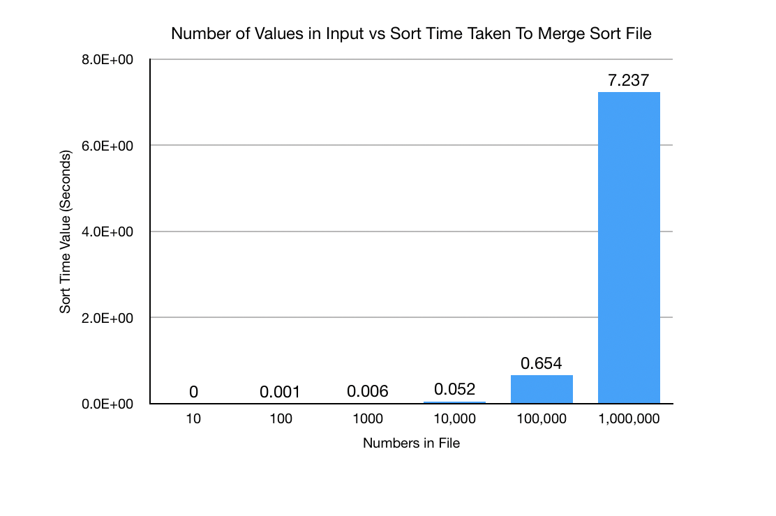

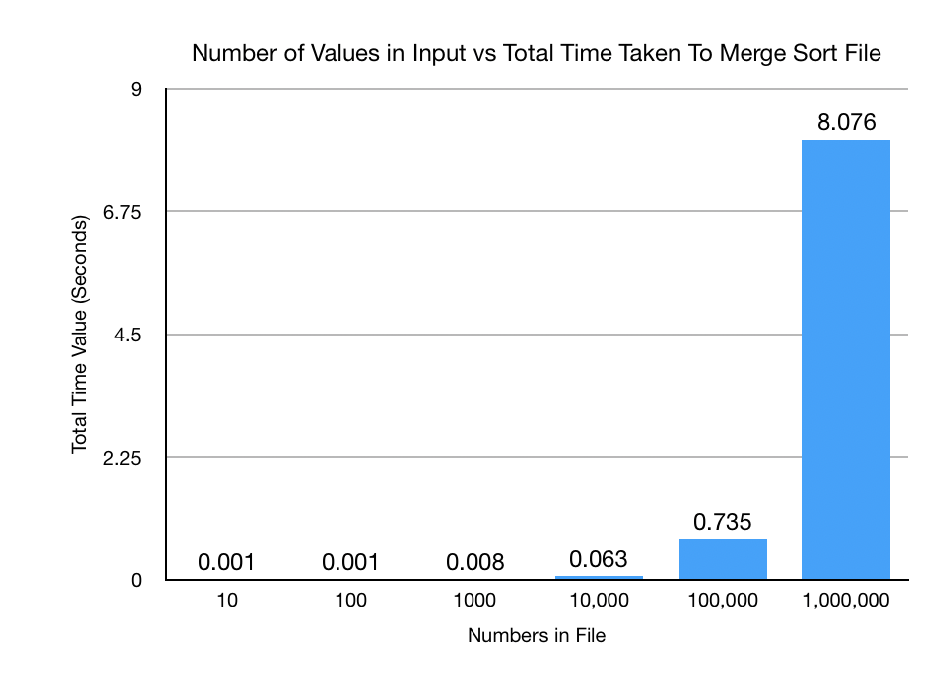

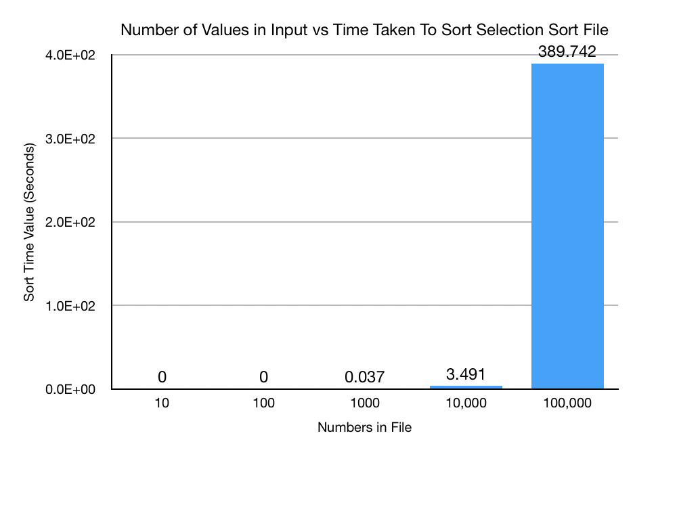

Sort time for selection sort is unknown, but it can be assumed that it is close to the approximate total runtime for the program.

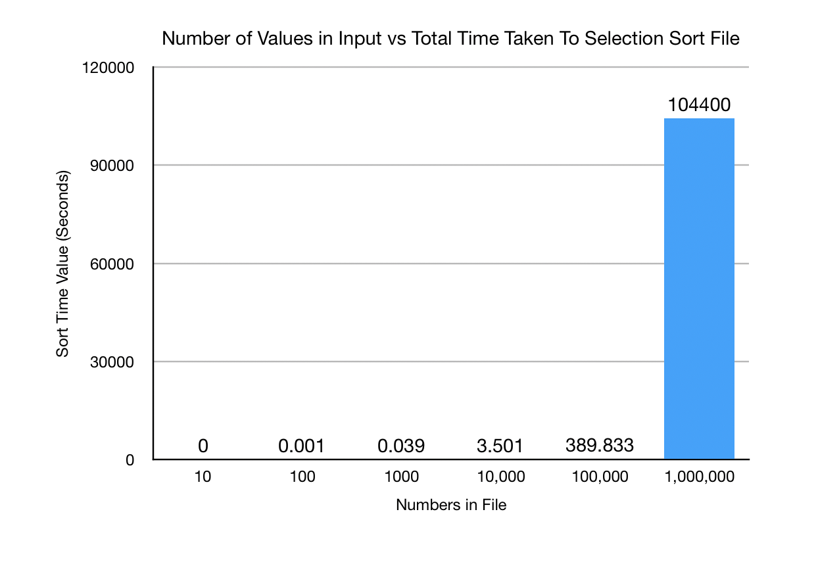

Percentages tell us that vast majority of program runtime is taken up by the sort algorithm. Runtime of inputting and outputting is negligible.

The graphs tell us that sort time increases exponentially as number of items to be sorted increases. It also shows that merge sort is significantly faster than selection sort.